This process is CRITICAL to show any projects (livestock and nonlivestock at the Union County Fair!
Important Reminders

All CLOTHING & COMMUNICATIONS entries must be submitted by June 15, 11:59 PM
All LIVESTOCK entries must be submitted by July 1, 11:59 PM
All STATIC (exhibit building) entries must be submitted by July 10, 11:59 PM

- Fair entries will begin being accepted into the fair starting June 2nd. Be sure to complete your entry (including the final “Submit” step) prior to the cut-off date.
- Register all entries for each exhibitor in the family before proceeding to the Payment section (fees only for beef)
- Be sure to click the “Submit” button when you have completed your entries. Entries are not final until they have been submitted.
- Check your email inbox for a confirmation email with a list of your entries.
- You will receive a second email when your entries have been approved by your fair.

Steps

Visit the Union County Fair Entry site directly at:
http://unioncountyfair.fairentry.com

Recommended browsers: Google Chrome or Mozilla Firefox. Other may cause unexpected behavior.

- 4-H Members: Log-In using the green “Log-In with 4-H Online” button. (Skip to step 5)  FFA Members: Click on the link to create a FairEntry Account. (After that, if you are logging back in, enter the email & password that you created and click the Sign in link.)  - Enter your email address twice and click Create Account. IMPORTANT: This must be a valid email address, so that you can receive the necessary confirmation messages.  - On the Account Creation page, enter information into the fields (all are required). Account Name, Phone, Password (enter twice to confirm).  - Click Create Account. | 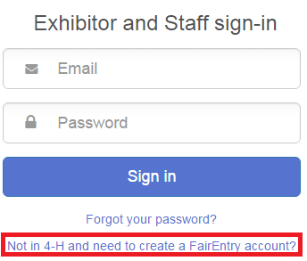
- Click “Begin Registration” | 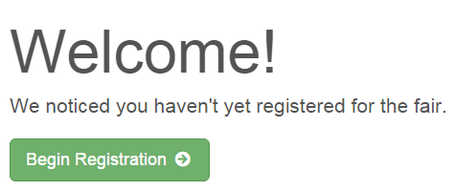
Exhibitor Information  If your fair is configured to accept both individual and team entries, click on the appropriate choice for your entry. Some fairs may only be configured for individual entries. | 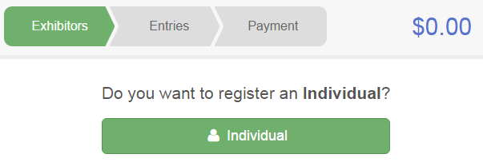
- Enter the information into the four fields—all fields are required. Click Continue when all information is entered. | 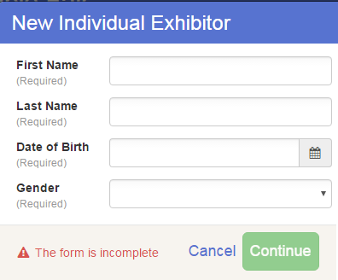
- (If you entered/spelled something incorrectly on the previous screen, you have the option to Delete this Exhibitor on this screen.) Enter the information on the Contact Info screen—the only required field is the top Home Phone Number. You can use the same email address that you used to create the account, or an alternate one. If you wish to receive text messages, enter your cell phone number and carrier. That number can be the same as the Home Phone Number entered above, or different. Click Continue when you are finished entering data. | 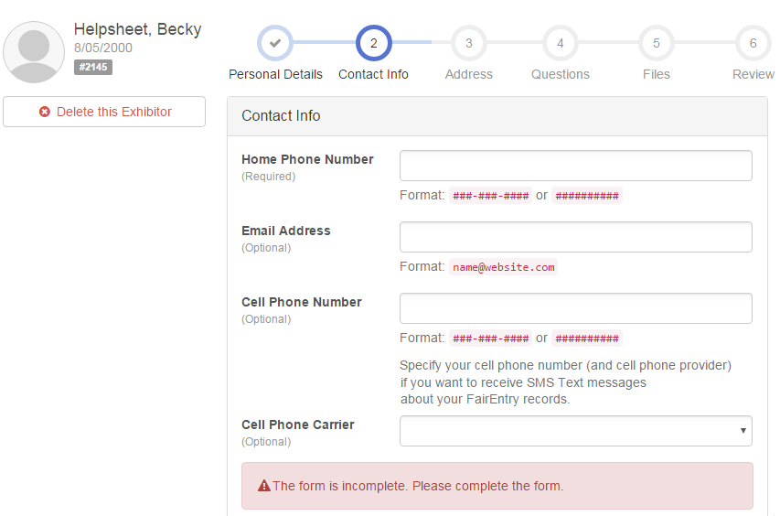
- Enter your mailing address. All fields, except Address continued, are required. As the on-screen help states, the address entered here will be used for mailing premium checks, etc. Click Continue when all information is entered correctly.  - If your fair set up custom fields/questions for you to answer, those will be step 4 on the progress bar at the top. Answer any questions, and click Continue.  - If your fair requires you to upload any files for your entry, those will be step 5 on the progress bar. Upload requested files, and click Continue. | 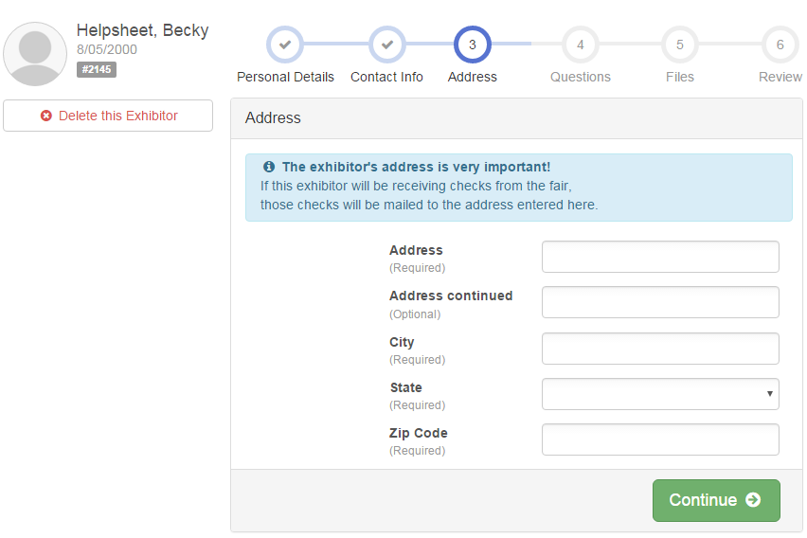
- Review your exhibitor information. If any information is incorrectly, click the green Edit button in the appropriate group to change it. When all information is correct, click Continue to Entries. | 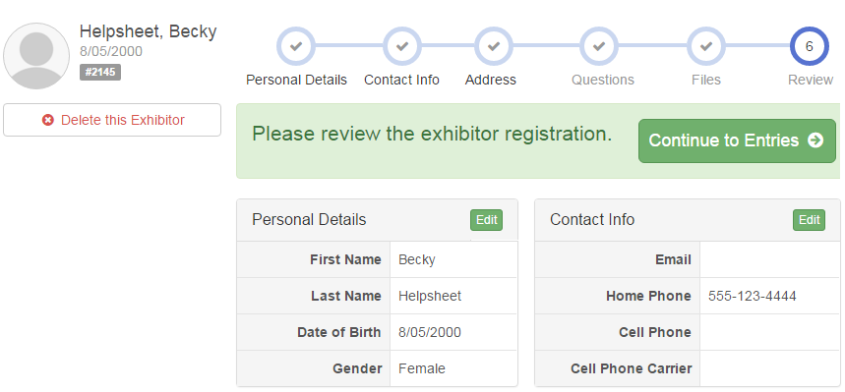

Creating Entries

Each exhibitor can have multiple entries. One entry must be made for each item, animal, class, etc. For example, if an exhibitor is bringing 2 photographs, two entries into the photography class must be created. If an exhibitor is showing one horse in 5 events, five class entries must be created. Once all entries have been created for the first exhibitor, you have the choice of creating another exhibitor in this family (and entries) or proceeding to check-out (submitting the entries, whether or not fees are charged).

- Click Add an Entry beside the correct exhibitor (if more than one has been created). | 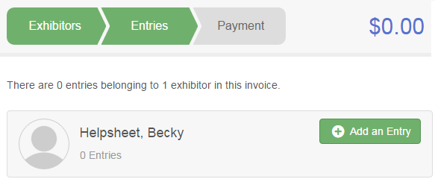
- Click Select beside the first department you wish to enter. Any departments that are not available for entry will be noted as “Not Available” with a short explanation.  - After you select a department, you will see a list of divisions to select from, and then a list of available classes. Also notice that there are blue “Change” links in case you mistakenly select an incorrect department, division, or class.  - After you have selected the class, click the green Continue button. | 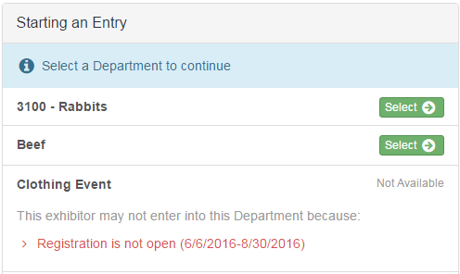
- If this is an animal class entry, you will be required to specify which animal will be exhibited in this class. If you are able to do that, you will see the option to “Add an animal”. KEEP IN MIND.. Class and animal changes can be made at check in at the fair.
- Fill in all of the fields with information about the animal you intend to exhibit. Click Create and Add Animal when finished.
- If the animal information was entered incorrectly, you have the option to either Remove From Entry (creating a new animal) or Edit Animal Details. When it’s correct, click Continue.
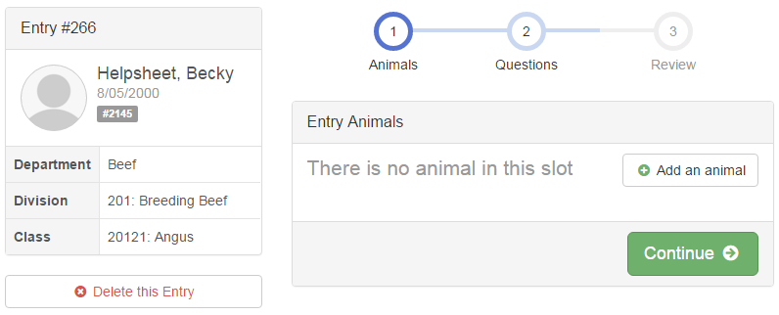
- Any questions or file uploads related to entry in this class will be next. Click Continue after answering those questions or uploading documents.
- The Review screen allows you to double check this entry for accuracy and make any changes necessary. When the information is correct, click Continue and that class entry is complete.
- When each class entry is complete, you have 3 choices for what to do next:  - If all class entries have been completed for one exhibitor, you can Register another Exhibitor in this family.  - If this exhibitor has more class entries to make, you can Add another Entry for this Exhibitor.  - If all entries for all exhibitors in the family have been completed, Continue to Payment to finalize and submit your entries. | 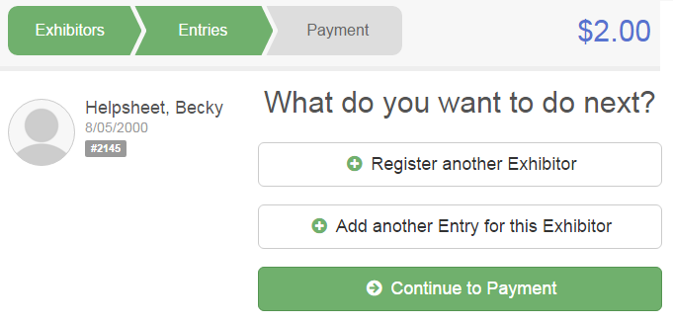
- Review your entries for completeness and accuracy. Notice the Summary and Detail buttons at the top of the list on the right. If there are errors, click on the green Entries section at the top of the page. Click Continue when all information is correct. | 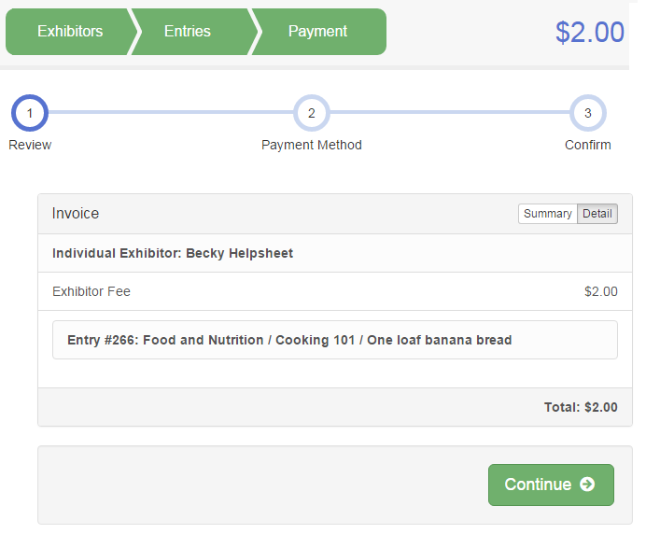

- Read the payment instructions and select your method of payment. Some fairs allow credit card payments, and others do not. NOTE: Even if you owe no money (no fees are charged) you must click Continue to the last “Confirm” step to submit your entries.

- Read the information in the “After you Submit” section. You may also have to check a box to “Agree to Terms”. Click Submit to finalize the entries for the exhibitors in this family. After you click Submit, no changes are possible to these entries.

