Entering Market/Weigh-In Animals in 4-H Online
NEW FOR 2021: 4-H Families will enter the Market Beef Weigh-In Data this year into 4-H Online

- ALL Market Beef data MUST be entered by families by February 1
- County 4-H Staff will review the weigh-in data for accuracy
- Ultimate animal data accuracy rests with each 4-H Family

Steps  1. Log in to your family account.  2. Click to View the Member’s record for whom you would like to add an animal. | (Screen appearance may vary per state)
3. Click Animals in the navigation pane.  4. Click the blue Register Animal button. | 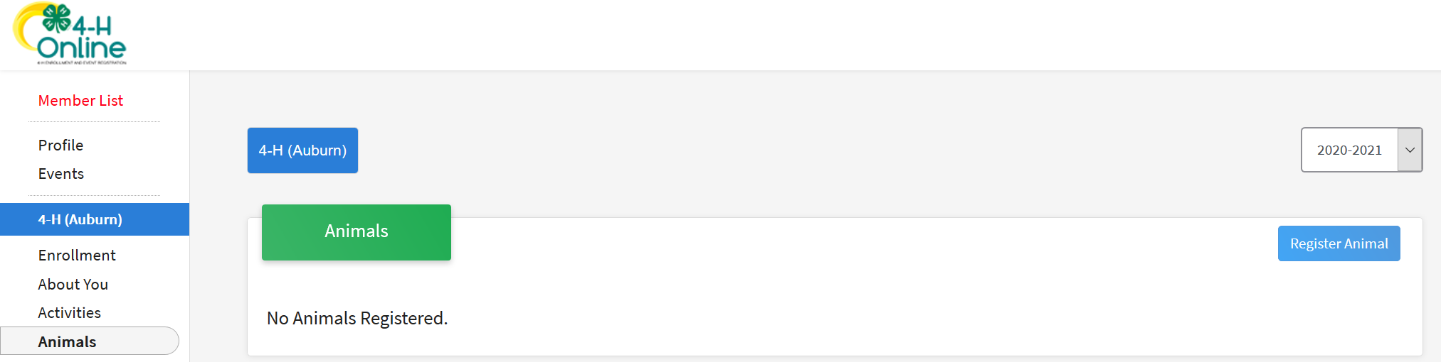
5. Click Add New Animal to start adding a new animal. | 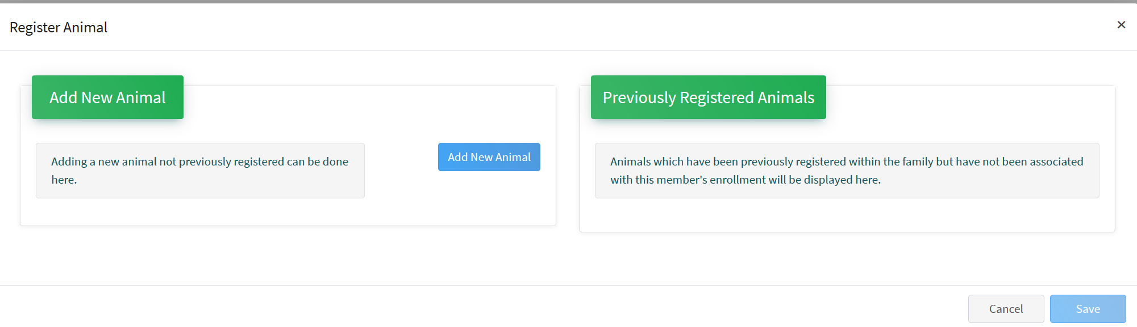
6. Select the appropriate animal type from the drop-down menu.  7. For market beef, select the “Beef, Market” animal type  8. Enter the required Tag, Tattoo, or Animal Name as directed.  9. Be sure to CORRECTLY enter the Ear Tag #:  - i.e. JJU1234  - Do NOT put the “42” or the county number in front  - Simply the 3 letters and 4 numbers (i.e. JJU1234)  10. Click Save. | 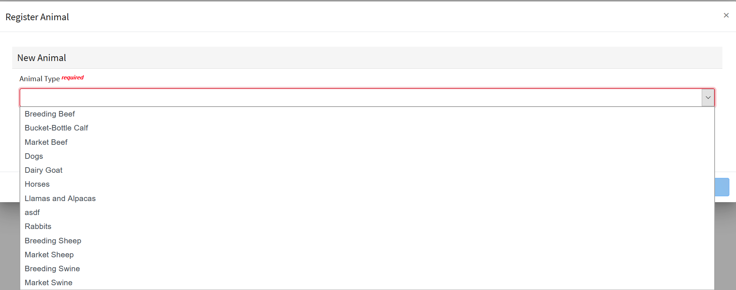  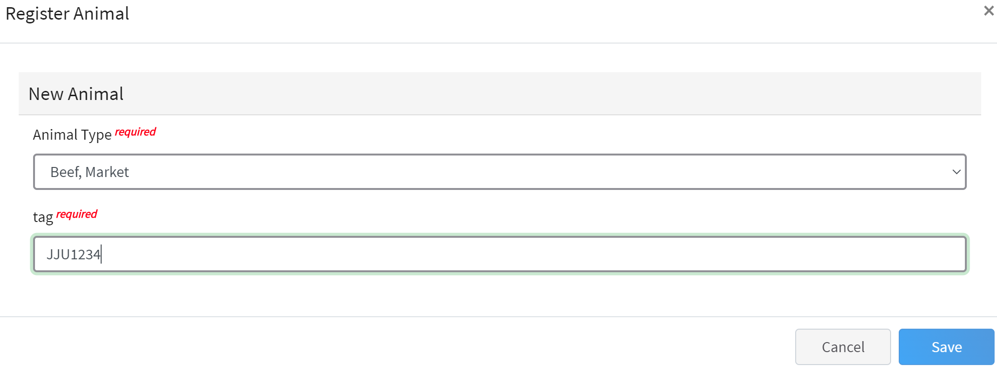
11. You will notice some IMPORTANT details and rules regarding the ID process – READ THESE CAREFULLY!!  12. Click on “Show Questions” to complete each of the required fields and optional fields as needed.  - Be sure the information is accurate especially:  - Beginning Weigh Date  - Beginning Weight  - Breed  - Retinal Images collected?  - Etc.  13. Click the Next button at the bottom of the form. | 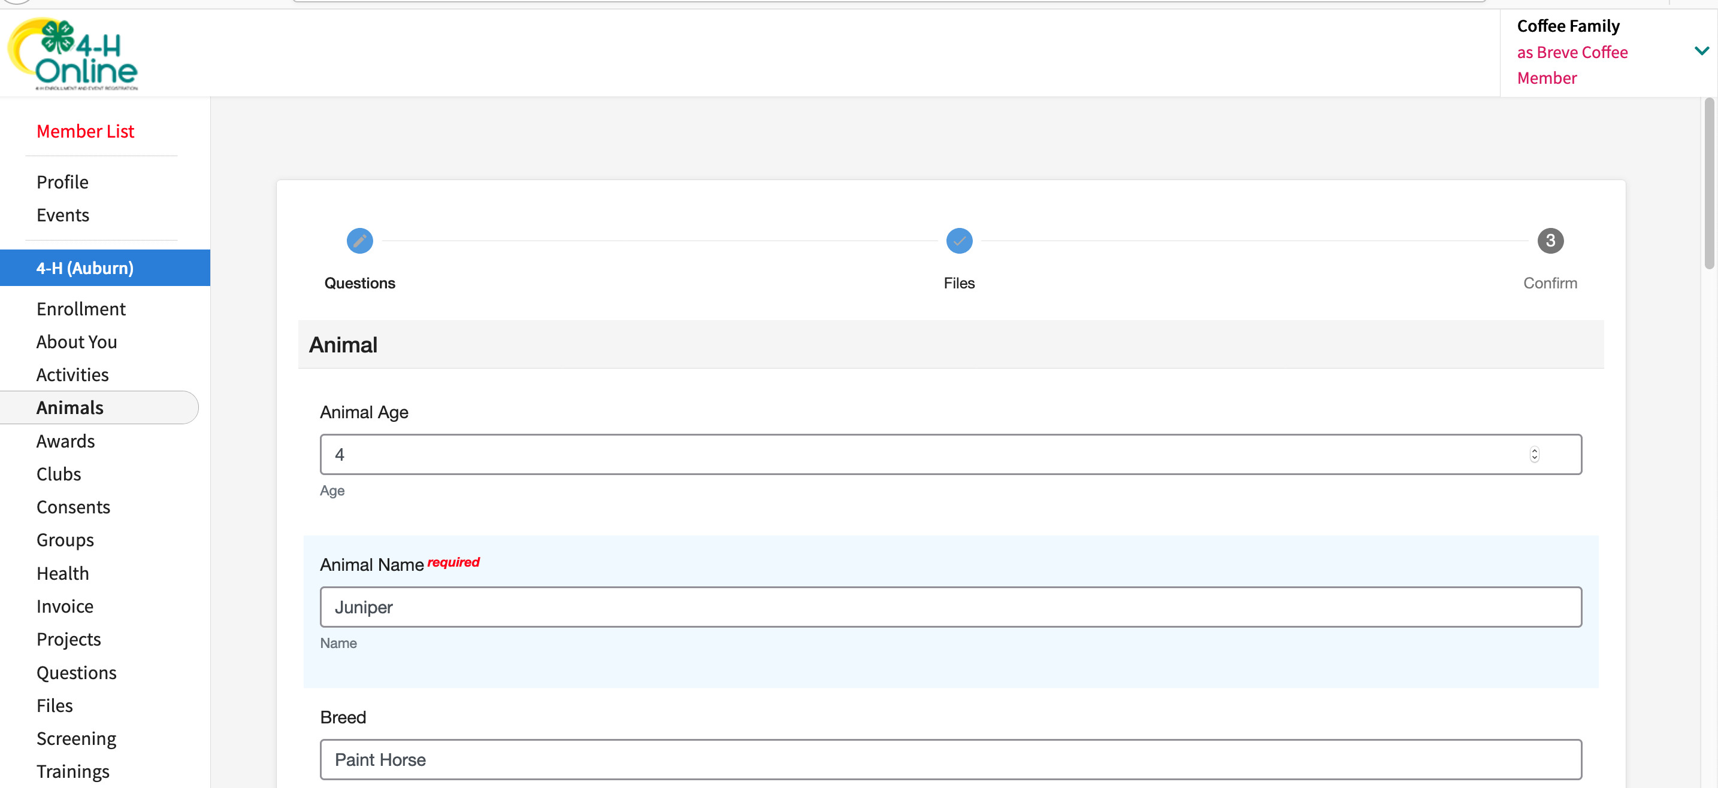
14. Upload any required or optional files for this animal.  - This could include pictures of the animal, etc.  - These file instructions are set up by county and/or state 4-H staff, if needed  15. Click the Next button | 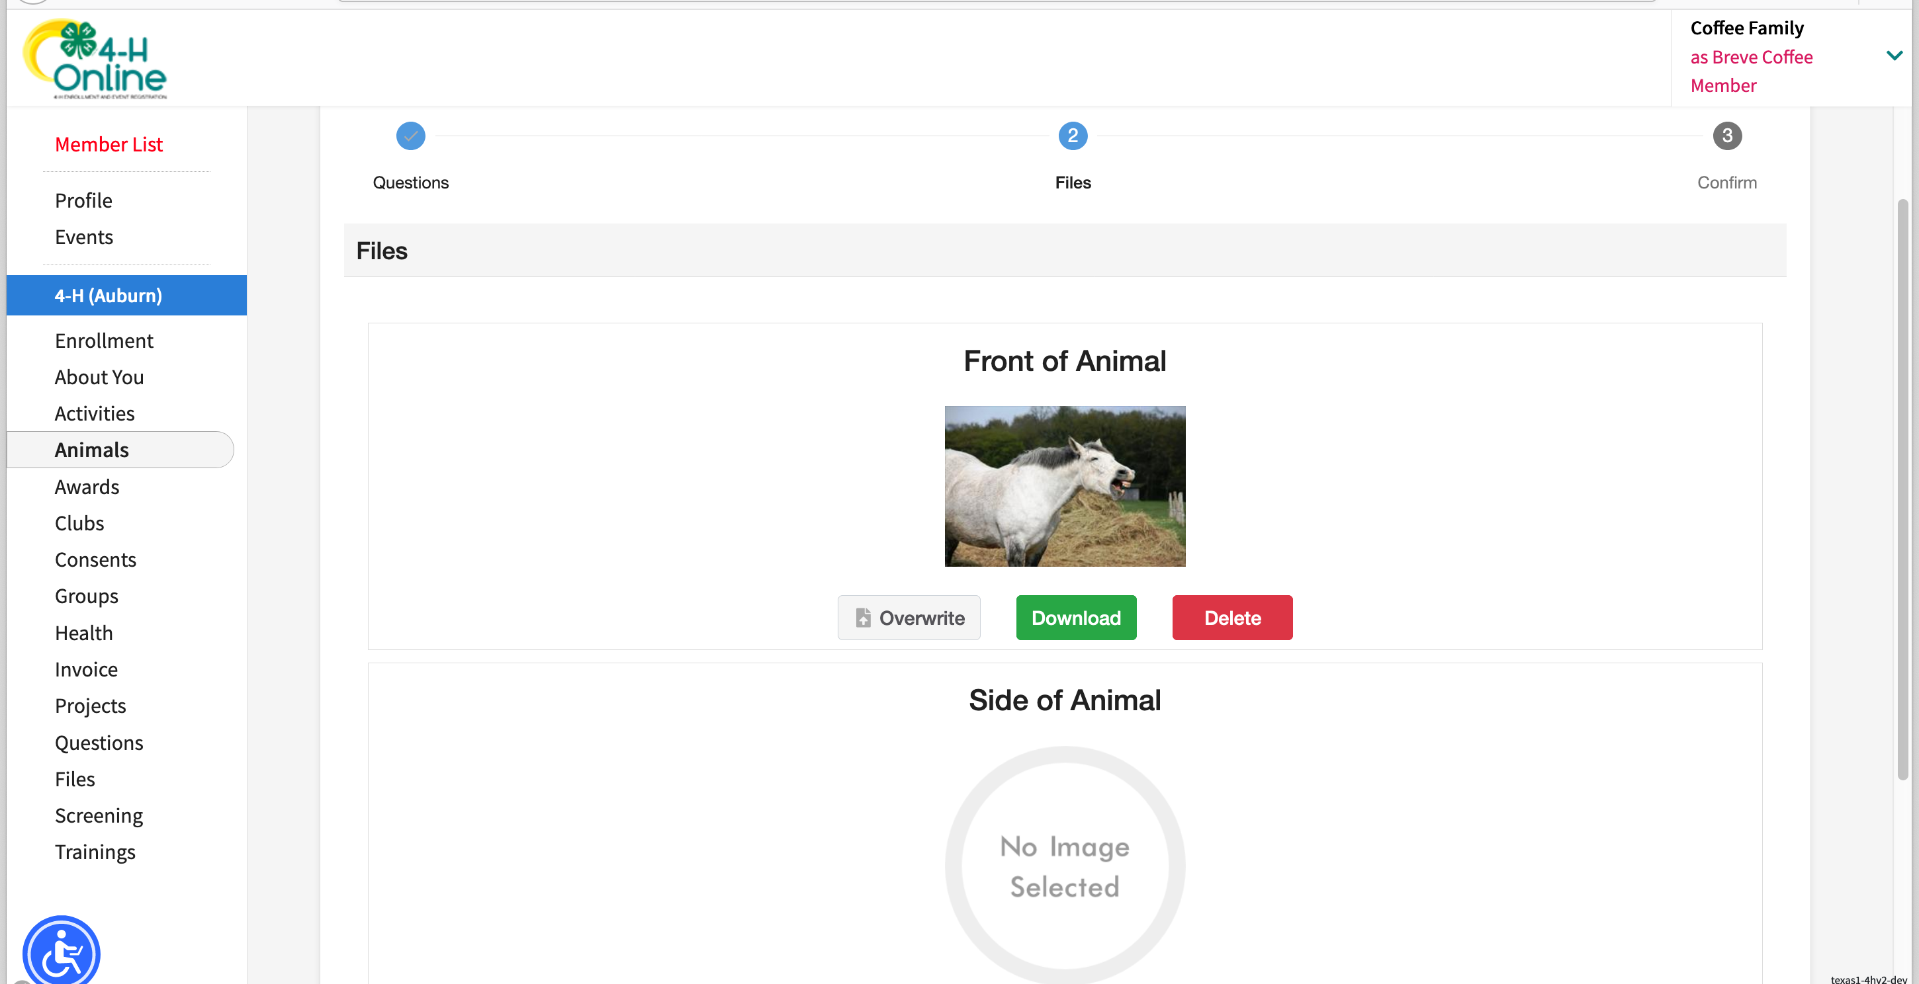
16. Review the entered information. Use the Back button at the bottom of the page to return to the previous screen to make corrections.  17. Once the entered information is correct and reviewed, click the Submit button. | 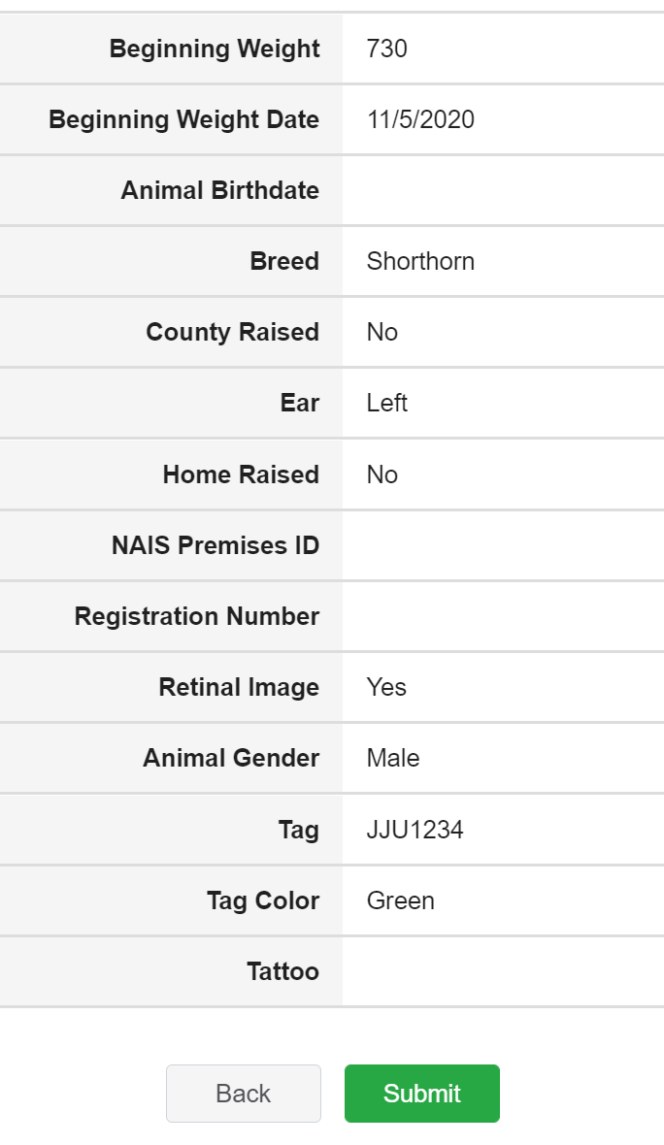
18. The animal information will display on the screen with the status, created, modified, and submitted date and time stamp (local time).  **Market Beef animals will automatically be active.  County 4-H Staff will review the animal data to make sure weights, weigh dates, etc. are correct.  - County staff will work with families to correct any incorrect information | 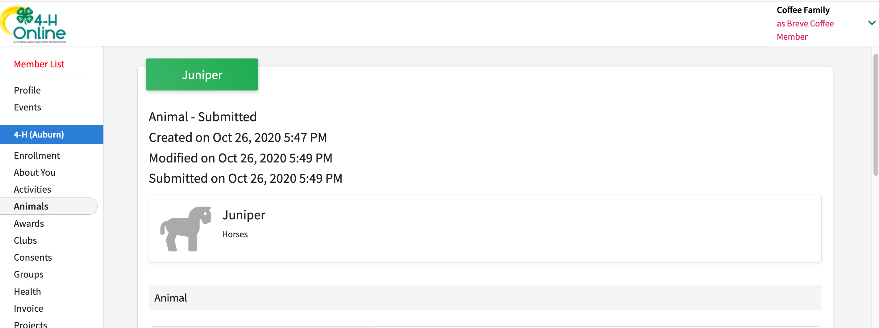
Click on the Animals tab from your account at any time to view the status for all of the animals for a member in the family.

